Contents
Analysis 3
Problem identification 3
The problem 3
Computational methods 4
Use of computational methods 6
Solvability through computational methods 7
Stakeholders 8
Target stakeholders 8
Stakeholder requirements 10
Solution usage 11
Meeting the requirements 13
Research 15
Already existing solutions 15
Features I could possibly use 18
Reasons and evidence for choosing these features 19
Essential features 20
Which features are essential 20
Why are these features essential (Questionaire) 21
Limitations 22
What are the possible limitations 22
Why do these limitations exist 23
Potential impacts of these limitations 24
Solution requirements 25
What will the final solution need to do 25
Hardware requirements 26
Software requirements 27
Evidence supporting these requirements (questionnaire) 28
Success criteria 30
How will I know if I was successful 30
How will I measure these criteria 31
Design 32
Decomposing the problem 32
Breakdown 32
Sub-problems in the bigger picture 34
Why the sub-problems are suitably sized 36
Structure 37
Algorithms 39
Main loop 39
Distance and force 40
Summing forces 40
Integration – symplectic Euler 41
Circular orbit 41
Collisions (merging) 42
Screen conversion and trails 43
Camera – zoom, pan, lock 43
Editing a body 44
Saving and loading 44
Readouts – Advanced mode 45
Scenarios 45
The complete solution 45
Usability features 46
Variables, Data Structures, Validation 48
Key variables 48
Data structures 50
Classes 50
Validation 51

Analysis

Problem identification

The problem

The problem that I am aiming to solve is GCSE and A-Level students’ issues with developing a deep and thorough understanding of orbital mechanics, gravitational interactions, and N-body situations. This is currently a relevant and serious issue, that I have personally experienced myself, as most students rely heavily on diagrams, books, videos or explanations (from teachers or friends etc.). These are the usual methods and are very limited in the ability to help develop a thorough understanding: there is no/ minimal interactivity/ experimentation, and they don’t allow for full involvement of the student with the learning environment. Students are unable to change aspects of bodies to view the effects that they have on things such as orbital periods, escape conditions and potential collisions. These are all highly critical to the A-Level/ GCSE spec(In circular motion, centripetal force, gravitational fields and force etc.) and are non-negotiable if a student wants to achieve high.
This lack of interactivity limits the possible understanding that students could have of the topics. Whilst students can memorise equations and patterns, this isn’t the case for topics that require understanding and issues become rooted deep within knowledge, limiting their performance. This is specifically noticeable when they attempt to visualize/ gain a strong apprehension of more intricate and difficult to process ideas such as how orbits are stable or how small changes can lead to immense changes in the wider picture etc. The project that I am going to complete will be customisable, it will display real-time N-body gravity simulations where the students using the program will be able to create and customise bodies and will detect and handle collisions and save/ load situations to or from JSON files for re-use.
This project addresses and serves as a solution to a real-world pitfall In educational simulations (precisely in physics): The already existing tools that I looked into are either too intricate/ expensive for an A level/ GCSE student – e.g. Universe sandbox, physics is much too simple and there is a lack of customisability - e.g. Solar system scope, or are website based and don’t have any save or load features – e.g. PhET My solar system. My solution will be made for and tailored for school issued laptops and will focus on the actual educative aspects to make sure that the original problem is properly addressed, rather than it turning into more of a game.

Computational methods

I have divided up the large main simulation into smaller sub-problems, such as: Representing the bodies – displaying the actual planets on the user’s screen and their trails/ names etc., Force calculations (done in pairs) – Calculating the forces between every pair of bodies (e.g. the force between earth and mars or the force between earth and the sun) at all times of the simulation running, Summing into one net resultant force – Calculating the final and resultant force to be applied on each body for that frame, Numerical integration – dividing time into tiny equal parts (dt) and then calculating all the forces between bodies at all steps before using the calculated forces to calculate new positions and velocities to be used for the next step, collision detection – Detecting and realising when two bodies have collided and what the result of the collision will be (new directions, velocities, accelerations etc.), Input handling (from the user) – Handling the users inputs to move the camera around, change the speed of the simulation etc. and actually getting the desired outputs/ results from those inputs, Saving/ loading the state – The ability of the program to reload the state it was in prior to ending (Saving the state in a JSON file for reloading) and to save it, The loop of rendering – The cycle of the program loading the frames based on the positions etc. of the bodies.
When calculating the initial force values, bodies will be divided into sets of unique pairs, interactions completed separately and all the relevant values for each interaction calculated before combining/ summing the forces per body and resulting in a final (resultant) force that can then be used to find the next velocity, position, acceleration etc.
In the simulation I will model the bodies themselves as point masses with only mass, position vector, velocity vector and gravity etc. – using Newtons inverse square law – ignoring many irrelevant and out of scope factors. The vector maths and integration etc. are going to be hidden from the user.
There is also lots of visualisation in this program as there is a constant, real-time output of the positions, trails, names and force vectors etc. to make the abstract and complex concepts in physics easier to visualise for the students.
I will also be keeping in mind O(N^2) complexity and the effects large amounts of bodies could have on the performance of the simulation while developing features – This is the idea that time taken to process an input increases quadratically with the size of the input (in this case the input is the amount of calculations that are needed to be completed). There could also possibly be FPS monitoring so that the user is aware of the effects on their FPS. Since this program will be designed for school laptops/ computers rather than high end PCs, the number of bodies will be limited to a certain constant to minimize the load and strain that is put on the lower-end hardware.
Algorithms are also constantly in use through things such as: Numerical integration (Euler method for calculating positions and velocities etc.), Collision algorithms – Constant distance checks (pairwise) to check if a collision has taken place, Vector operations – Constant calculations to check what the positions of vectors should be updated to in the next frame.
Altogether, these methods turn the initial physics problem into a much more manageable solution.

Use of computational methods

Nearly all the core features of the program rely on computational methods in some way, for example:
- Summing of forces and integrations taking place in real time – Decomposition is used for splitting it into pairwise calculations, Divide and conquer is used for combining the split pairs back into one resultant force, Algorithms are used for the constant calculations taking place (Euler method and numerical integration etc.)
- Adding/ removing custom bodies in real-time – Abstraction ignores many irrelevant qualities of the bodies such as shape, composition etc. and models them as point masses instead
- Collision detection – Algorithms constantly monitor distances between every pair of bodies and whether they have collided or not
- Visual trails/ vectors etc. and zooming in or out – Visualisation is used to create graphics for the trails and display the solar system differently based on how much you zoom in/ out or move around
- Saving/ loading – Data persistence is used to save or load simulation states to or from JSON files for re-use
These features all demonstrate how the features of the simulator all rely on computational methods.

Solvability through computational methods

There is very complex physics that takes place “behind the scenes”, however this gets reduced to many smaller and more tractable steps through the use of algorithms: calculating distance, determine inverse square forces as vectors, sum forces pairwise, divide by mass for the acceleration, update velocity and position through the tiny time steps (dt). The calculations and concepts that are in effect during the simulation become much clearer and easily digestible through visualising them as graphics: The trails show the elliptical paths that the planets have taken as they orbit, The collisions show how planets could interact with each other, The distances between bodies and the sizes put the size of the solar system and planets relative to each other into perspective for the students.
Furthermore, there is strong evidence from already existing simulations/ studies that these sub problems, and eventually the whole main problem, are all suitable to be solved through computational methods. Examples include:
- Princeton university: 3.4 Case Study: N-body Simulation – This N-body case study demonstrates the O(N^2) integration that I was looking to use. This shows how the number of calculations needed increases quadratically with the increase of the number of bodies, n, as each body interacts with each other body. This study also displays how positions and velocities of bodies can be effectively updated using Euler integration – specifically the “leapfrog method” in which you use the updated velocity instead of the old velocity to update the position – to produce accurate results. This all confirms that the methods I plan on using are sufficient for visualising the interactions.
- Deadlock code (YouTube): Making an N-Body simulation – In this video, “Deadlock” explains how it is made possible to calculate pairwise forces effectively by using Eulers method (The method I intend to use) and by ignoring repeated steps to increase efficiency and reduce the time taken to perform all the calculations required.
- Deadlock code (YouTube): How to make HUGE N-Body simulations – “Deadlock” here proposes an alternative for O(N^2) and instead uses O(Nlog(N)). Through this, he is able to simulate thousands if not millions of bodies simultaneously smoothly. To achieve this, he takes a group of bodies as one large body with a total mass and average centre of mass to greatly reduce the number of calculations that are required to find the pairwise forces. I could implement this feature if the user decides to introduce a large number of bodies.
These examples altogether show that real-time N-Body simulations are more than suitable to be solved through computational methods.

Stakeholders

Target stakeholders

The primary stakeholders that this Solar System Simulator will be aimed at are GCSE and A-Level physics students/ their physics teachers. To describe the possible usage and utility this program would have for these two groups, I have created three personas based on typical UK state-school teachers and students that fit into the groups. These personas will be facing the challenges that I mentioned in the problem identification section, and I will demonstrate how this program could be a solution.

- Student persona 1 – Charlie: Charlie is 16 years old, is in year 11 and studies AQA G.C.S.E separate higher physics at school. Charlie consistently scores 60% in mock exams for the topics “Forces and motion” and “Gravitational fields”. Charlie finds orbital mechanics, centripetal force and calculations with N-Bodies tremendously difficult and perplexing, as the textbooks that he normally learns from feature only static diagrams, the teacher explanations only last 10-15 minutes and don’t match his learning style and the YouTube videos he watches only have set situations and he is unable to customize them to suit his own unique ones. Charlie uses a standard school-issued laptop (Dell latitude 3310) which has minimal specs – low RAM, integrated graphics, slow processor etc. He also currently isn’t particularly affluent meaning that he doesn’t have enough money to spend anything on a program. Charlie needs a program that is completely free, offline works without admin rights (school laptop), allows customisation, has clear visuals and saves scenarios for later review. Charlie also struggles to visualize situations that rely on “what if” scenarios, such as “what if the earths mass was doubled”. Experimenting with these scenarios would assist in heightening his understanding and his comfortability with these topics.

- Student persona 2 – Keyan: Keyan is 17 years old, is in year 12 and studies AQA A-level physics at school. Keyan is predicted an A* and is particularly keen for astrophysics. He understands the basic equations that were taught in the teacher explanations but lacks an intuitive “feel” which he hopes to develop. Keyan has access to a slightly better home PC but still doesn’t have any high-end equipment. Keyan mainly wants a tool that he can experiment with and mention in applications/ interviews. He needs the simulation to be accurate and dependable so that it can be used to generate evidence for personal projects to be included in applications.

- Teacher persona – Mr Kulczyk: Mr Kulczyk is an adult physics teacher that teaches both A-level and G.C.S.E AQA physics. He teachers 3 G.C.S.E classes and the 2 A-level classes. He is responsible for instructing on and demonstrating many different principles regarding orbital mechanics. The physics department at the school which Mr Kulczyk teaches at lacks sufficient funding to purchase a Universe Sandbox license for every single student and the schools already in place IT policies block most online tools. Ideally, Mr Kulczyk would have a single downloadable executable. It would support pre-made JSON files for typical lesson scenarios, have controls (pause, change speed, camera movement, reset etc.), and produce a clear visual, displaying things such as vectors and trails to help students with picturization.

Included in the secondary stakeholders are:
- The schools IT technicians - They must whitelist and download the program onto all the student-used devices
- The parents/ carers – They can help with home revision whilst using the program
The entire design of the simulation will however be driven mainly by the needs of primary stakeholders - students/ teachers such as Charlie, Keyan and Mr Kulczyk. This is as they are the end-users which it is aimed at and will be interacting with it most often.

Stakeholder requirements

Charlie’s requirements for this program include:
- Customisation of the physical properties of the bodies (e.g. mass, radius etc.) so that he can evaluate the “what if” scenarios – PhET does not allow for full customisation of the bodies, only mass
- Visuals that can help build understanding, such as trails (colour coded), force-vector arrows, zoom/ pan controls
- Alignment with AQA G.C.S.E specification
- Reliable performance on the school hardware – e.g. minimum 30 FPS with up to 20 bodies, on—screen FPS counter
- Fully functional save/load feature – through JSON files
- Clean GUI that is simple and easy to use/ understand (and hides all the maths taking place
Keyan’s requirements for the program include all of Charlie’s along with:
- Customisation of the physical properties and a real-time display of other values – Position as a coordinate, Acceleration vector, Velocity vector etc.
- Good performance on his own PC with a higher number of bodies e.g. 30
Mr Kulczyk’s requirements include:
- Controls that make the program suitable for use in classroom demonstrations/ lessons – this includes things such as being able to pause the entire simulation so that he can explain scenarios to the class, slow down the simulation to give live explanations and speed up the simulation to show effects over larger periods of time
- The software must be free so that it can be installed and used with all the students without using any of the physics department’s limited budget
- The program must be able to run offline (It can’t be on a website)
- Must be able to load or save specific situations so that he is able to carry on previous lessons or create situations prior and load them to show his class
One thing that is required by all the stakeholder personas is the simulation to feel more educational rather than game-like, as the main purpose and issue that I am aiming to solve is the lack of resources suitable to assist learning with orbital mechanics (specifically in low-budget schools/ in areas with more financially challenged students).

Solution usage

Charlie will make use of this program through:
- Independent discovery sessions: Charlie will spend some time each day messing around with the simulation and a blank JSON file. He will add bodies himself and experiment with different scenarios to develop a better intuition and understanding of orbital mechanics. He will also make use of the vectors and periodic pausing/ slowing down the simulation greatly to observe what is really taking place in terms of velocities and positions. Charlie could also take notes of his findings and come back to them each session to develop them further
- Targeted revision after challenging topics/ sections: Whenever the teacher goes over a specific section or topic that Charlie doesn’t fully understand by the end, he can experiment with ideas and situations that his teacher mentions in class to help strengthen and gain a complete understanding
- Assistance with homework: Charlie can either be set homework specifically on the simulation – such as having to experiment with specific concepts or situations and supply screenshots of findings, or separate homework that he can get assistance with from the simulation – for example, If his teacher sets homework on the effect on the orbit of earth over time from increasing its velocity or mass by a certain amount, Charlie can apply the changes to the base simulation (the standard simulation) and then speed it up and observe/ note the changes that take place
Keyan will use the same usage methods as Charlie alongside these:
- More in depth and complex independent experimentation sessions: This can include setting up many simulations and running them after each other, all while recording differences and interpreting what the cause could be/ predicting what the change in path will be after another value is altered.
- Personal projects: Keyan can create and save multiple complex multi-body scenarios exporting screenshots to build up a report/ write up on different laws/ theories as mini personal projects he can pursue and eventually include in his UCAS personal statement when applying to universities
- Assistance explaining concepts: When in his peer-tutoring sessions with the younger students, Keyan can utilise the program to explain complex topics and help the tutee gain a stronger intuition and understanding in terms of situations that are governed by orbital mechanics
Mr Kulczyk can embed the simulator into his already made teaching sequence to make it easier to grasp concepts:
- Whole class live demonstration: Mr Kulczyk can project the program onto the classroom screen, load a pre-made JSON file showing a basic orbit and start the simulation. He can run this at normal speed and narrate and possibly go on to slow it down and add velocity arrows to show circular motion and the force exchanges that take place in real time
- Guided student practical: Every student can load the program on their device (likely a school laptop – which it was designed for) and run an empty simulation. Mr Kulczyk can guide them through the steps to make a system for the first time. Afterwards, he can set them tasks ranging in difficulty to be completed independently or in groups on the program. Screenshots can be saved in the class teams chat
- Flipped learning/ homework: Mr Kulczyk can share pre-made JSON files to the students for them to observe and experiment with and come to a conclusion that can be shared with the rest of the class during the lesson, before learning the concepts that govern these observations. Mr Kulczyk can also set tasks for homework based on the lesson taught to solidify their knowledge
- Open evenings/ days: Mr Kulczyk can have the simulator running on a big screen at any events that involve parental engagement. He can demonstrate this program and how to use it, explaining all the benefits to the learning of the students

Meeting the requirements

This real time N-body solar system simulator will meet every single requirement of Charlie, Keyan and Mr Kulczyk with extreme accuracy as every feature and quality of it was engineered with the exact hardware available, curriculum and desired features in mind at all times.
For Charlie (G.C.S.E), the core aspects of this program, such as the live pairwise force calculations and the adjustability of body qualities give him the instant and unrestricted interactivity that the previously used static diagrams could not. The O(N^2) performance modelling, that gives him a hard cap on the number of bodies that he can have active at one specific time, allows him to run the program at a good standard even on the low performance hardware that he was provided by the school. The state persistence using JSON files solves the issue that he would have experienced with solutions such as PhET – the inability to save experiments for later work/ display etc. Charlie can now close the program at 2 pm if he runs out of time and continue at 7pm when he is more free to finish his project. Visible and colour-coded trails, force vectors, zoom controls and pan controls make the once abstract concepts much simpler to understand as an interactive and visual simulation. This directly addresses Charlies issues with visualisation and developing a deeper understanding and intuition than from memorisation alone.
For Keyan (A-Level), the same foundation goes further with more advanced features to support his learning at a higher level. Displaying the properties of bodies, toggleable force vectors and a higher body cap all allow Keyan to fully and properly explore more advanced concepts at a greater depth. The state persistence through JSON files allows Keyan to save projects for display on his portfolio.
For Mr Kulczyk (Teacher), the pre-made library of JSON files that can be used for lessons, convenient classroom controls (pause, speed up, slow down, zoom, pan) and the ability to save and share JSON files solve the issues of having to prepare examples, not being to explain at his own/ the classrooms pace in lesson and the inability to set projects for classwork/ homework to be interacted with by the students that he would have faced normally. Now, rather than spending 45 minutes creating diagrams and hunting for suitable videos, he is able to load a demonstration within a minute and spend more time and focus on the actual teaching aspect. The educational focus of the simulation also means that it slots into his existing lesson plans seamlessly. The range of features that are toggleable and optional make it extremely suitable and convenient for him to go between his A-Level and G.C.S.E students/ classes. The program is also 100% offline, free and runs perfectly on school hardware, it removes all barriers that prevented him from using other tools.
In summary, every computational method and feature chosen were selected specifically to directly address the original issue and bridge the educational gaps for G.C.S.E physics students, A-Level physics students and Physics teachers alike. The range of features and customisability also even makes it suitable for anyone who is looking for a simulator that can be simultaneously fun and interesting/ educational. This direct addressing makes it not only suitable – it is the only tool that satisfies the exact curriculum for both A-Level and G.C.S.E physics, provides high levels of customisability and interactivity and is completely free, all while being suitable to be ran on school hardware. Through this project, I will deliver exactly what these stakeholders require in a form that they will be willing to use every day and therefore result in much greater student understanding, engagement and performance overall.

Research

Already existing solutions

There are several already existing tools that attempt to address the same issue that I am aiming to solve – visualizing orbital mechanics and gravitational interactions. The main three solutions that I researched in depth are:
- PhET My Solar System (University of Colorado Boulder) – A browser based, free and interactive solar system simulator
- Universe Sandbox (Giant Army) – A commercial and paid physics-based universe sandbox game
- Solar System Scope (EASE) – A 3D solar system visualisation tool (web, desktop and mobile versions)
PhET My Solar System
Currently, this free tool is the most used across UK schools. It starts with the option to choose between an introduction to the tool and the lab – in which you can experiment as you desire. In the lab there are a selection of scenarios you can use, however in the custom option the maximum number of bodies is 4, limiting the possibilities of what you can create. It allows users to set their mass, position and velocity. It includes trails, an adjustable gravity strength and displays real-time gravitational interactions. It is very easily accessible and aligned with GCSE topics. However, in most schools and school devices, almost all websites are blocked, which could possibly include this website, meaning it would need to be whitelisted by the IT team. Additionally, on low spec, school provided laptops, websites are extremely slow to load, making this very inconvenient.
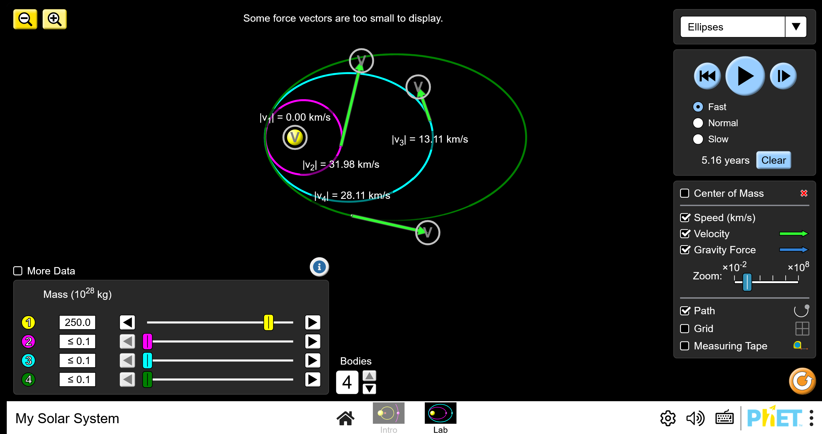
Universe Sandbox
This N-body simulator is professional-grade, supporting dozens of bodies, very realistic collisions, tidal features and high-quality 3D graphics. It performs very well with “what if” and experimentational scenarios however this high quality comes with a high cost as a result. Educational discounts are available but full licenses still cost approx. £20-30 per user, which would go heavily over the budget for the physics department due to the high number of students studying the subject.

Solar System Scope
This simulation focuses on a highly accurate 3D visualisation of the real Solar System at any point in time using data from NASA. This simulator boasts features such as night sky AR, planet exploration and extremely accurate scales. There is very minimal interactivity with the actual simulation (other than exploring planets) and physics experimentation.

Features I could possibly use

Each of the solutions have their own strengths and helpful features, however the features that I might implement into my own simulator include:
- A very clear and concise GUI with real-time body creation/ editing (mass, radius, position, velocity, colour) using sliders, buttons and possibly click to place – Taken from [PhET] My Solar System and Solar System Scope
- Trails and vector visualisation (coloured coded trails showing paths and labels on each body) – taken from [PhET] My Solar System and Solar System Scope
- Dynamic camera controls (zooming and panning) – taken from Solar System Scope and [PhET] My Solar System
- Simulation controls (play/ pause, speed up, slow down) – taken from Universe Sandbox and [PhET] My Solar System
- Preset/ Example scenarios – taken from PhET My Solar System
Additional features not included in any of those solutions that inspired me to add them in mine:
- JSON Save/ Load system that allows state persistence
- Performance monitoring

Reasons and evidence for choosing these features

My reasons for the features included in existing solutions:
- [PhET] My Solar System’s GUI, trails, simulation controls and presets make it very convenient and tailored towards GCSE students like Charlie, giving the students preset situations that are relevant to GCSE, meaning it will heavily assist in improving their understanding of orbital mechanics and gravitational interactions, and therefore these features will help my solution line up with problem and be more efficient
- Universe Sandbox’s advanced simulation controls and realistic physics will be extremely difficult to replicate in my project, while sticking to my timeframe and restrictions. However, although I can’t take entire features, I can still take inspiration or small parts such as the vectors, controls and parts of the GUI. The simulation controls will give the students more control over the simulation and therefore more freedom to experiment with any situation needed
- Solar System Scope’s intuitive, visually pleasing GUI and the ability to select a specific planet/ body and observe the qualities, such as mass, velocity, radius etc. are both features that I will be attempting to replicate in my own project as an easy to use and good looking GUI can encourage students to use the program more and therefore increase their understanding at a higher rate, resulting in the problem being solved faster and more efficiently
My reasons for the features that weren’t included in the existing solutions I investigated:
- JSON save/ load system: None of the three tools have an easy to use save/ load system for custom scenarios. The absence of this feature forces students/ teachers to recreate scenarios each session and prevents the preparation of reusable lesson files. Addieng this feature will allow Charlie to save schoolwork for further development at home, Mr Kulczyk to build a library of ready to use demonstrations and let Keyan build a repertoire of personal projects to be used for his portfolio
- Optimisation for school equipment: Since all my main stakeholders are either students or teachers, the program will be made with the aim of being used on school equipment in mind. This includes limiting body counts, making it run from a python file and not web based.

Essential features

Which features are essential

After a thorough analysis of the problem and the possible stakeholders, I have identified the following features as essential to the ability of the program to reach the goals I have in mind.
- Real-time N-body physics engine/ calculations
This is the core feature of the entire simulation as it allows gravitational forces between bodies to be calculated and gives each body a direction to travel
- Custom body creation and editing in real-time
This is the ability for users to create/ delete bodies and modify certain aspects (mass, radius, position, velocity, colour) while the simulation is running
- Visualisations and interactive tools
This feature includes the toggleable force and velocity vectors, the dynamic zooming and panning of the camera and the body labels
- Simulation controls
Being able to play/ pause the simulation at any time and change the speed to slow down or speed up the simulation. Also includes being able to lock on a selected body
- JSON save and load system
Full state persistence of the simulation state at any time into JSON files that are human-readable
- Numerical readouts
Show values such as speed, force, orbital period etc. for a selected body so that students can make links to equations
- Pre-made scenarios
JSON files that are ready to load for common topics

Why are these features essential (Questionaire)

I have chosen these as my essential features as they are what will directly address the core problem that I am trying to solve - the lack of completely interactive, customisable, and accessible tools for learning/ experimenting with orbital mechanics and N-body dynamics - while simultaneously fully satisfying the needs of all of the stakeholders that are involved.
- The real time N-body physics engine, custom body creation and scenario editing are fundamental as without these, the program wouldn’t have the real-time gravitational simulations and experimentation, meaning that students like Charlie wouldn’t be able to go beyond the static diagrams and un-interactive videos to develop a real conceptual understanding – The main issue that I am addressing.
- The visualisation tools (I.e. trails, vectors, camera controls) and the simulation control are highly essential as to turn the complex calculations and logic taking place into visuals that can be observed by the students. This will help with Students like Charlie’s issues with visualisation and teachers such as Mr Kulczyk’s demonstrations in class.
- The state persistence and save/load features through JSON files are critical as they are what make it possible to have pre-made lesson scenarios. This saves time for the teacher and students. The teacher rated save/ load as a 4/5 and pre-made scenarios as a 5/5, and also confirmed that they would use the simulator by displaying pre-made scenarios for entire class demonstrations. None of the existing solutions that I conducted research on featured saving custom scenarios.
In summary, I have selected these features as they are necessary to create the minimum viable solution that closes the educational gap that I have identified as my problem. Every feature that I have marked as essential is justified by either; a stakeholder requirement, a limitation of an existing tool (such as PhET, Universe Sandbox and Solar System Scope) or the need for the program to be practical and usable within a school environment, and every essential feature scored a minimum of 3/5 on the teacher questionnaire.

Limitations

What are the possible limitations

Although I have thoroughly analysed and focused the project to fit stakeholder needs, I can still identify several limitations. I can group these into technical, practical and developmental constraints.
Technical:
- Performance limitations – The simulation I am creating uses pairwise force calculations, which has an O(N^2) complexity. This means that the frame rate and performance overall will drop significantly as the number of bodies increases
- Hardware – The program that I am making is specifically designed for school laptops therefore it should run well on low spec devices, however on especially low-end devices, it might not be as smooth.
Practical:
- Simplified model for physics – The bodies involved in force calculations are only modelled as point masses and Newtonian gravity. The simulation doesn’t include more advanced effects and concepts.
- 2-Dimensional simulation – The simulation is limited to 2D to make visualisations simpler and easier to understand, performance, simplicity of calculations and mainly to allow the entire project to fit into my scope.
Developmental:
- Time and skill – As this is only an A-Level NEA, my developmental time is limited to the deadlines set and my scope is constrained by my level and expertise at programming.
- Single user application – This program is only going to be designed as a single user desktop application and won’t support real-time collaboration, however a more advanced version of this project could possibly be adapted to include this feature.

Why do these limitations exist

The performance and hardware constraints have been introduced as this project is aimed and targeted at real school environments, including those that lack the required funding to provide all students with high end laptops/ desktops. This means that I am required to limit the performance needs of the code to make it suitable for my stakeholders.
This NEA project has a limited timeframe, and I also need to balance it alongside my EPQ dissertation writing and research, my Physics revision, Mathematics revision and Computer Science revision. The time required for this will increase near exam periods and therefore my time spent on this NEA will decrease temporarily, however, to combat this issue I have limited the simulation to 2 dimensions and simplified the physics (modelling bodies as point masses), making it all more tractable. Adding 3D or more complex physics would take the project outside of my scope and make it unrealistic to complete within set deadlines.
I am a single A-Level student working on this project. Therefore, my skill level is limited and the amount of work that I can get done is also restricted by the fact that I am a single developer.
The missing multi-user features exist as the primary focus of this project is meant to be on the individual student learning and classroom demonstrations, rather than real-time multi-user usage.

Potential impacts of these limitations

The performance limits (O(N^2) complexity) mean that users – such as Keyan and Charlie – will be restricted to smaller solar systems. However, for the expected usage of this program, the limits shouldn’t influence its functionality, as smooth performance will still be achievable with enough bodies to perform classroom demonstrations for all the concepts involved in G.C.S.E and A-Level physics.
The simplified 2D model means that the program will lack the ability to look at the solar system with a z-axis as well, however this is not integral for the demonstration of the main concepts required to be understood. This may also slightly reduce the immersion of the students when compared to other solutions, such as universe sandbox, however this program remaining completely free compensates for this.
Although these limitations are present, I have carefully considered each of them and mitigated them whenever possible. These constraints also ensure that my project remains realistic and achievable instead of overly ambitious. I will revisit these limitations at the evaluation section to assess the actual impacts that they had on my final product.

Solution requirements

What will the final solution need to do

The final product of this project must be a complete and interactive tool for learning and experimentation, addressing the problem that I identified in the problem identification section.
This involves being able to:
- Simulate accurate gravitational interactions between a number of bodies in real time
- Allow for easy creation, deletion and editing of bodies in real time (mass, radius, position, velocity, colour)
- Display trails to display the path taken by the body and that are colour-coded to match the body
- Have toggleable vectors for velocity
- Have an easy-to-use zoom/ pan camera
- Have labels on top of each body for easy identification
- Allow the user to pause/ play the simulation at any point in time
- Allow the user to change the speed of the simulation (0.1X – 10X)
- Allow the user to lock the camera onto and follow a specific body
- Support complete saving/ loading simulation states from JSON files

Hardware requirements

This solution doesn’t require any extra hardware that aren’t already built into a laptop, such as:
- Mouse (touchpad already built into laptops) – for panning the camera around, zooming in and out and possibly selecting bodies
- Keyboard (already built into laptops) – For using key bound features, such as pause, play, save, load etc. and for typing in values when creating/ editing bodies
- Monitor (Screen already built into laptop) – For displaying the visuals

Software requirements

This program is going to be developed in python 3.11. The requirements for it to run properly include:
- Python – To run the actual code
- The Pygame library – Used for graphics and user input
- JSON module – Used for data persistence
This program will be able to run as a standalone .py file. Therefore, no internet connection or paid software will be required after the initial installation.

Evidence supporting these requirements (questionnaire)

The requirements that I have defined in the previous sections have been derived from multiple sources:
Question | Response
Year groups / exam board | G.C.S.E and A-Level / AQA
Difficulty of orbital mechanics, gravitational fields, circular motion (1–5) | 3, 4, 3
Resources currently used | Textbooks, teacher-led explanations, YouTube, PhET
Biggest challenge | “Students find it difficult to develop an intuition of orbital mechanics – lack of exposure”
Real-time body creation/ editing | 3
Save/ load (JSON) | 4
Persistent trails | 4
Toggleable force/ velocity vectors | 4
Collision detection | 3
Zoom and pan | 5
Play/ pause | 5
Adjustable speed | 5
Simple/ Advanced mode | 5
Numerical readouts | 5
Pre-made scenarios | 5
Performance on school laptops / free / offline importance | 5 / 3 / 4
Other features wanted | None
Would they use it in lessons? | Yes – offline use helps in rooms with poor internet
Requirement | Evidence
Real-time gravity simulation | Teacher’s main challenge is lack of exposure; Princeton N-body case study
Create/ edit/ delete bodies | Teacher 3/5; supports “pause, change, predict” use; Charlie’s “what if” needs
Trails and vectors | Teacher 4/5 each; present in PhET
Zoom/ pan, play/ pause, speed control | Teacher 5/5 each; Mr Kulczyk’s classroom needs
Save/ load, pre-made scenarios | Teacher 4/5 and 5/5; none of the three tools allow saving
Numerical readouts, simple/ advanced mode | Teacher 5/5 each; Solar System Scope body info; PhET Intro/ Lab
Collision merging | Teacher 3/5, so simplest realistic outcome first
FPS counter, body limit | Teacher 5/5 for smooth performance; Dell Latitude 3310
Offline .py program | Teacher 4/5 for offline; their comment on poor internet
Free | Teacher 3/5; Charlie’s persona (limited budget)
Lock camera onto a body, labels | Not covered by the questionnaire – based on research; to be tested during stakeholder review

Success criteria

How will I know if I was successful

Once I am complete with this project, I will consider it a success if the following criteria have all been fully met. I have developed these criteria by directly considering the stakeholder requirements, essential features and my research into already existing solutions.
- Accurate and realistic physics
The simulation must maintain stable orbits. I will test this by checking the error in orbital periods in comparison with my theoretical calculations, and base the accuracy on the percentage error
- Real time customisation
The user must be able to create, delete and modify properties of bodies, such as mass, velocity, radius, colour, position etc. with immediate effects that are visible in the simulation
- Functional save/ load system
The user must be able to both save or load simulation states with complete accuracy. All properties of all bodies must be preserved. I can compare screenshots right before saving the simulation and right after loading the simulation to check any errors.
- Stability/ reliability
The program must be able to run for 30 minutes continuously without crashing when using up to 20 bodies, to simulate classroom tasks
- Performance on school hardware
The program must maintain a minimum of 30 fps with 15 bodies on a Dell Latitude 3310 – A common school laptop given to students
- Educational visualizations
The user must be able to toggle velocity vectors and colour coded trails on or off instantly with a single button
- Practical visualisations
The user must be able to zoom/ pan with a mouse/ touchpad and body labels must be toggleable and display above the corresponding body
- Usability for classroom demonstrations
The program must be able to slow down/ speed up from a range of at least 0.1X – 10X, to make it convenient for classroom demonstrations

How will I measure these criteria
Criterion | How measured | Target | Linked to
Accurate physics | Compare simulated orbital period with T = 2π√(r³/GM) over 5 orbits; check total energy drift | Under 1% period error (adjust after testing) | Teacher: orbital intuition; Princeton study
Real-time customisation | Create, edit and delete bodies during a run; check effects are immediate | 100% of properties editable | Charlie; teacher 3/5
Save/ load | Compare screenshots and property values before saving and after loading | Identical values | Teacher 4/5; PhET gap
Stability | Run for 30 minutes with 20 bodies | No crashes | Teacher: performance 5/5
Performance | Read the FPS counter on a Dell Latitude 3310 (or similar) with 20 bodies | At least 30 FPS | Teacher 5/5; Charlie
Visualisations | Toggle vectors and trails | One key press, instant | Teacher 4/5
Camera/ labels | Zoom, pan and label toggle at min and max zoom | Works at all levels | Teacher 5/5
Speed control | Test 0.1X to 10X | Full range works | Teacher 5/5; Mr Kulczyk
Readouts | Compare with hand calculations | Within 1% | Teacher 5/5
Scenarios | Load each scenario and check behaviour | At least 4 work | Teacher 5/5
Modes | Switch modes mid-run | No reset; tools hide/ show | Teacher 5/5
Collisions | Compare momentum before and after a merge | Within 1% | Teacher 3/5
Robustness | Test with bad and boundary input (test table) | No crashes | Rubric: robustness
Stakeholder usability | Teacher feedback form after development | Mean at least 4/5 | All stakeholders

Design

Decomposing the problem

Breakdown

My big picture problem is to create a real-time, interactive and educational N-body gravity simulator that A-level and G.C.S.E physics students and/ or teachers can use in classroom on a Dell Latitude 3310 laptop. To make this manageable, I have decomposed it into smaller, more tractable sub-problems:
- Physics engine
I will need to create a system that calculates gravitational forces between every pair of bodies. I will use Newton’s inverse-square law, sum up the resultant force on each body and update all positions and velocities accordingly (Using Euler and/or Leapfrog integration).

- Body management
This involves the ability to create, edit (e.g. mass, radius, position, velocity, colour) or delete selected bodies in real time.

- Collision detection/ response
This requires continuously checking distance between each and every pair of bodies, implementing a limit to decide when the bodies have collided, and determining what the outcome should be (bounce or merge).

- Visualisation
This includes drawing bodies, colour coded trails, (toggleable) force/ velocity vectors, body labels and handling zooming/ panning.

- Simulation controls
I will need to implement the ability to play/ pause and adjust the simulation speed.

- Data persistence
This involves being able to save the state of the whole simulation – all bodies and qualities.

- User interface
I must provide the user with a clean GUI where they will be able to edit all settings of the simulation, possibly including a simple and advanced mode.

- Performance monitoring
This requires an FPS and body counter that works in real time, displaying warnings when performance limits are neared.

Sub-problems in the bigger picture

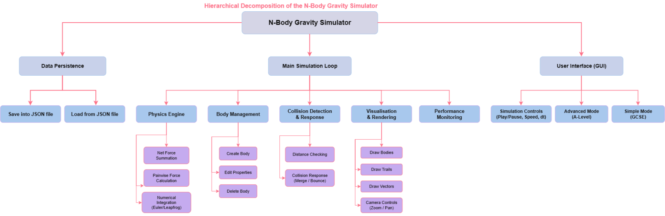
These sub-problems, once combined, form a tight system, as can be seen in this top-down hierarchal diagram.

The main simulation loop holds all of the required functions to successfully run the simulation. This includes:
- Physics engine – The core of the solution. Every frame, this engine will receive the list of bodies from the body management section, allowing it to calculate pairwise forces, and update pspotositions/ velocities.
- Collision detection – Checks positions of all bodies and may alter the list, due to merging.
- Visualisation
- Collision detection and response
- Simulation controls and user interface
- Data persistence
- Performance monitoring
These functions when combined form a cycle that will repeat continuously as my program runs: Input PhysicsCollisionsRenderPerformance checkRepeat. I will make sure that sub-problems are able to be edited without breaking any orders as they will only interact with each other through the list of bodies.
Sub-problem | Code | Development stage | Success criterion tested
Physics engine | calculate_distance, calculate_gravitational_force, calculate_all_forces, apply_symplectic_euler | Stages 1–5 | Accurate physics
Body management | CelestialBody, add_random_body, editing panel | Stages 2, 13 | Real-time customisation
Collisions | check_for_collisions, merge_bodies | Stage 9 | Collision handling
Visualisation | draw_body, draw_trail, draw_velocity_vector, convert_simulation_to_screen | Stages 6, 7, 11 | Educational and practical visualisations
Simulation controls | pause flag, simulation_speed, camera lock | Stages 5, 13 | Usability for classroom demonstrations
Data persistence | save_simulation, load_simulation, to_dictionary | Stage 10 | Save/load
User interface and modes | draw_control_panel, mode | Stage 12 | Usability
Performance monitoring | FPS counter, body counter | Stage 12 | Performance, stability

Why the sub-problems are suitably sized

These are the reasons for why each of my sub-problems are of suitable size:
- Testable alone – I can test each sub-problem alone. E.g. I can test the physics engine without any collision handling or any interface.
- Not too complex and not too deeply integrated – Certain functions, such as calculate_distance are functions within a sub-problem, rather than sub-problems of their own. If combinations were larger – such as “physics and collisions” would make finding errors and debugging significantly more complicated. This is because issues could be caused by either.
- Order – I can build my project in an order that results in a working and testable program after every stage, allowing for easy review.
- Realistic – I am a single student and have a limited time frame, so they aren’t too large or complex to complete within my limitations.

Structure

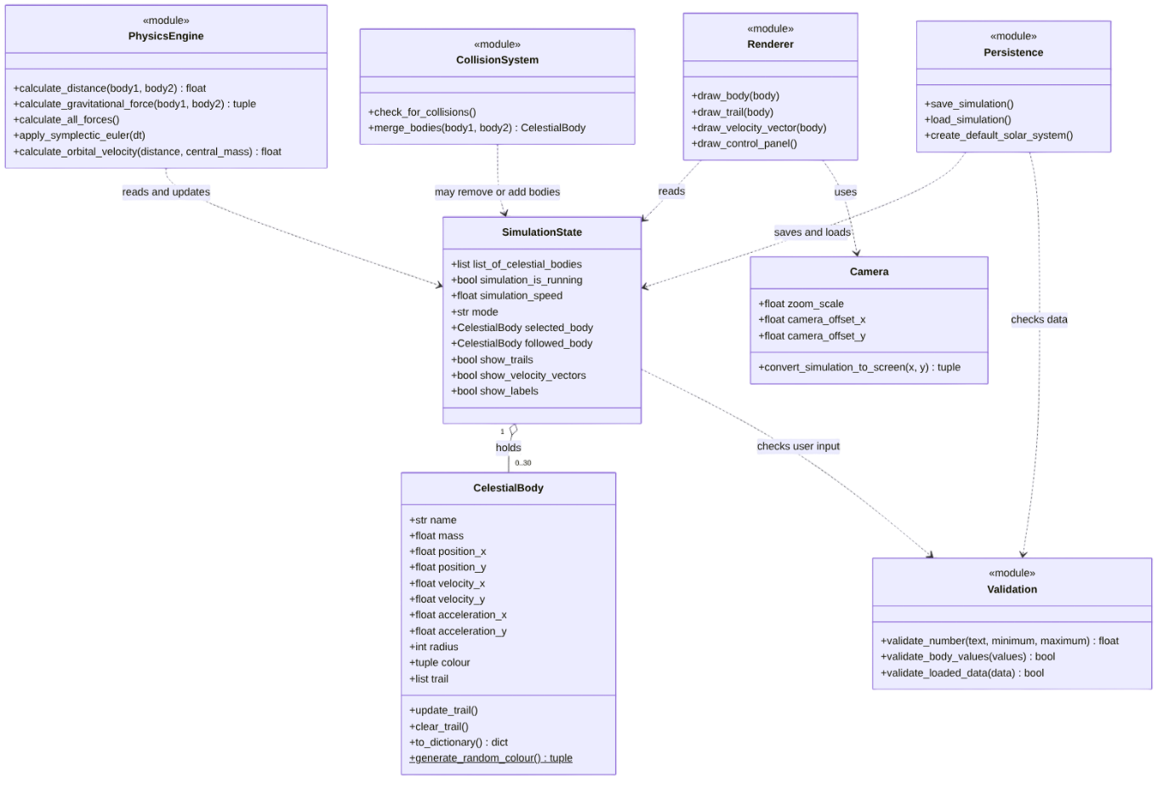
Figure A – Class diagram. The program only uses one class (CelestialBody), which stores all of the data for the bodies. SimulationState holds the list of 30 bodies and any flags that control the program. The remaining are groups of functions. Each sub-problem never contacts another directly, keeping them separate.

I decided to only use a single class, rather than multiple such as planet and star etc. as each body – while they may represent different things – behave the same. Therefore, adding another class would make it more complex while keeping the exact same functionality.

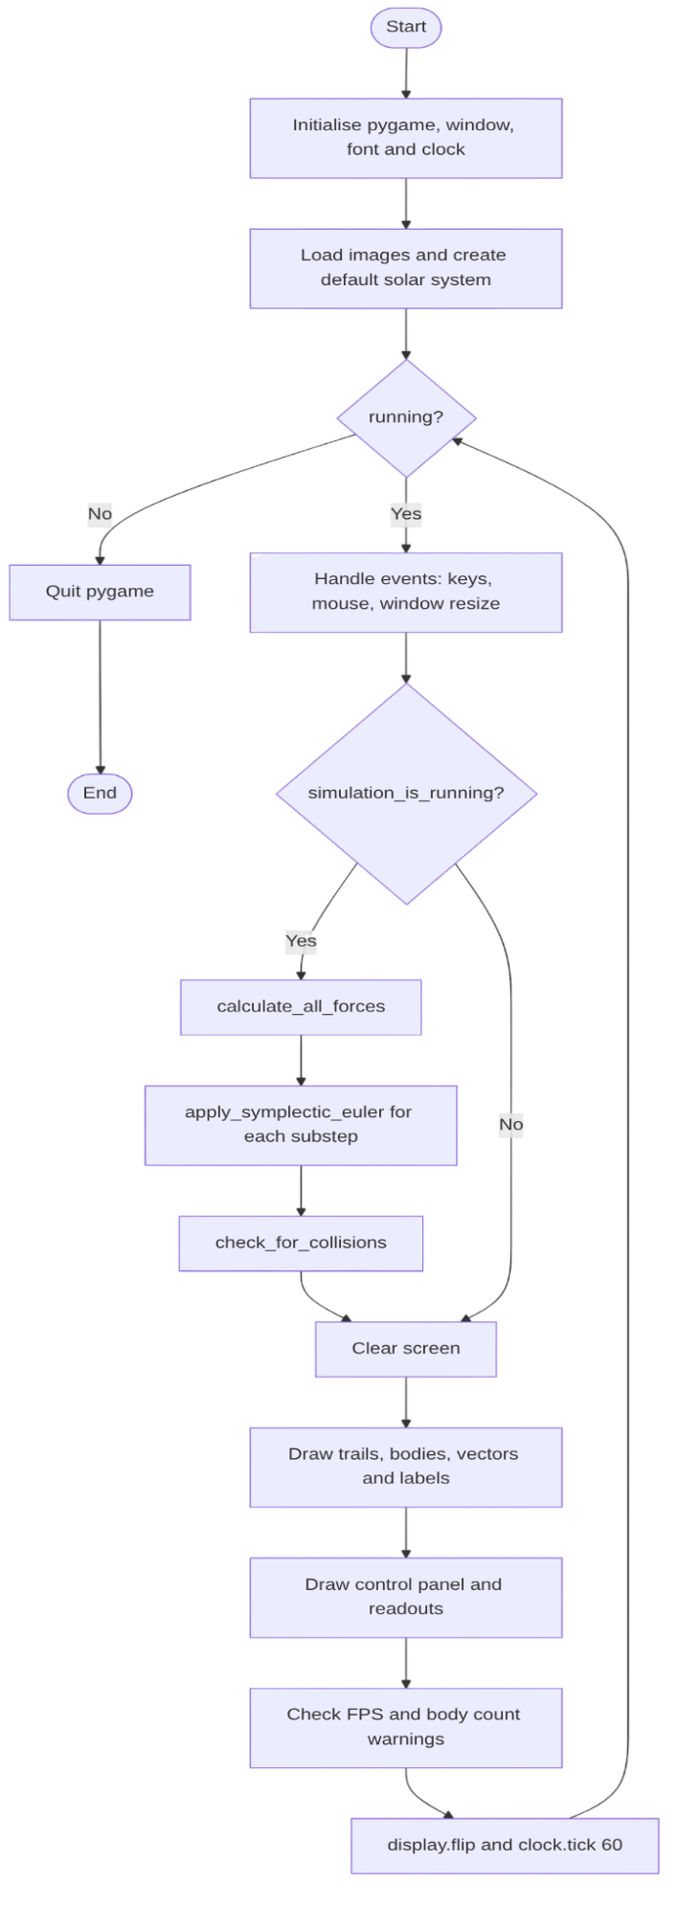
Figure B - Main loop flowchart. This diagram displays the order in which sub-problems run. Physics and collisions only run while the simulation is not paused, however drawing always takes place. This allows the user to inspect the simulation while paused.

Algorithms
procedure main()
initialise_pygame()
create_default_solar_system()
running = true
while running
handle_events()
if simulation_is_running then
substeps = ceil(simulation_speed)
dt = TIME_STEP * simulation_speed / substeps
for step = 1 to substeps
calculate_all_forces()
apply_symplectic_euler(dt)
check_for_collisions()
next step
check_values_are_finite()
endif
if followed_body != null then centre_camera_on(followed_body)
draw_frame()
update_performance_warnings()
clock.tick(60)
endwhile
pygame.quit()
endprocedure

Main loop
I used a fixed TIME_STEP constant so that results are consistent regardless of performance. If sim speed is increased, the number of substeps increases to maintain accuracy.

Distance and force
function calculate_distance(body1, body2)
delta_x = body2.position_x - body1.position_x
delta_y = body2.position_y - body1.position_y
return sqrt(delta_x^2 + delta_y^2)
endfunction

function calculate_gravitational_force(body1, body2)
distance = calculate_distance(body1, body2)
if distance < 0.001 then distance = 0.001 // prevents division by zero
magnitude = G * body1.mass * body2.mass / distance^2
force_x = magnitude * (body2.position_x - body1.position_x) / distance
force_y = magnitude * (body2.position_y - body1.position_y) / distance
return force_x, force_y
endfunction

Here I used Newton’s Law [F = Gm1m2/r^2]. The direction of this force is determined by dividing displacement by distance, returning a unit vector.

Summing forces
procedure calculate_all_forces()
for each body in list_of_celestial_bodies
body.acceleration_x = 0
body.acceleration_y = 0
next body
for i = 0 to n - 2
for j = i + 1 to n - 1
force_x, force_y = calculate_gravitational_force(body[i], body[j])
body[i].acceleration_x = body[i].acceleration_x + force_x / body[i].mass
body[i].acceleration_y = body[i].acceleration_y + force_y / body[i].mass
body[j].acceleration_x = body[j].acceleration_x - force_x / body[j].mass
body[j].acceleration_y = body[j].acceleration_y - force_y / body[j].mass
next j
next i
endprocedure

Here I calculate the x and y acceleration pairs for every pair of bodies using Newton’s second law re-arranged. These accelerations are then applied to both bodies involved using Newton’s third law.

Integration – symplectic Euler
procedure apply_symplectic_euler(dt)
for each body in list_of_celestial_bodies
body.velocity_x = body.velocity_x + body.acceleration_x * dt
body.velocity_y = body.velocity_y + body.acceleration_y * dt
body.position_x = body.position_x + body.velocity_x * dt // uses NEW velocity
body.position_y = body.position_y + body.velocity_y * dt
body.update_trail()
next body
endprocedure

I looked into a few Euler methods, and this is what I found to be most suitable. It is simple and is “cheap”. Most importantly, it keeps orbits stable while remaining accurate.

Circular orbit
function calculate_orbital_velocity(distance, central_mass)
return sqrt(G * central_mass / distance)
endfunction

The centripetal force that keeps the bodies from flying off in this case is gravity. Therefore Gm/r^2 = v^2/r. This gives me v = sqrt(GM/r). I apply this velocity to each planet – magnitude applied perpendicular to the radius.

Collisions (merging)
procedure check_for_collisions()
to_remove = []
new_bodies = []
for i = 0 to n - 2
for j = i + 1 to n - 1
if body[i] not in to_remove and body[j] not in to_remove then
if calculate_distance(body[i], body[j]) < body[i].radius + body[j].radius then
new_bodies.append(merge_bodies(body[i], body[j]))
to_remove.append(body[i]); to_remove.append(body[j])
endif
endif
next j
next i
remove every body in to_remove from the list
add every body in new_bodies to the list
endprocedure

function merge_bodies(a, b)
total_mass = a.mass + b.mass
new_x = (a.mass*a.position_x + b.mass*b.position_x) / total_mass // centre of mass
new_y = (a.mass*a.position_y + b.mass*b.position_y) / total_mass
new_vx = (a.mass*a.velocity_x + b.mass*b.velocity_x) / total_mass // conserves momentum
new_vy = (a.mass*a.velocity_y + b.mass*b.velocity_y) / total_mass
new_radius = (a.radius^3 + b.radius^3) ^ (1/3) // volumes add
keep the name and colour of the heavier body
return new CelestialBody(...)
endfunction

This is likely the least realistic part of my simulation, however it is the most realistic outcome that is simple enough to fit within my scope. I am taking into account the fact that the teacher rated realistic collision outcomes (bouncing or merging) as 3/5. Adding a bouncing feature is an optional extension that I likely wont pursue.

Screen conversion and trails
function convert_simulation_to_screen(sim_x, sim_y)
screen_x = sim_x * zoom_scale + camera_offset_x
screen_y = sim_y * zoom_scale + camera_offset_y
return integer(screen_x), integer(screen_y)
endfunction

procedure draw_trail(body)
if show_trails and length(body.trail) >= 2 then
for i = 1 to length(body.trail) - 1
brightness = i / length(body.trail) // older points are darker
faded = body.colour * brightness
draw_line(faded, convert(body.trail[i-1]), convert(body.trail[i]))
next i
endif
endprocedure

There is only one conversion function for anything that needs to be moved onto the screen. If there were separate ones and something was wrong with one, it would result in bodies appearing to drift out of line. I also added fading to the trails for a better visual.

Camera – zoom, pan, lock
on mouse wheel up: zoom_scale = min(zoom_scale * 1.1, MAX_ZOOM)
on mouse wheel down: zoom_scale = max(zoom_scale / 1.1, MIN_ZOOM)
on right button held and mouse moves:
camera_offset = drag_start_offset + (mouse_position - drag_start_mouse)
if followed_body != null then
camera_offset_x = SCREEN_WIDTH / 2 - followed_body.position_x * zoom_scale
camera_offset_y = SCREEN_HEIGHT / 2 - followed_body.position_y * zoom_scale
on window resize: recalculate the centre from the new SCREEN_WIDTH / SCREEN_HEIGHT

Editing a body
procedure edit_selected_body(field, text)
value = validate_number(text, minimum_for(field), maximum_for(field))
if value is invalid then
status_message = "Invalid " + field + ": must be between ..."
else
selected_body.field = value
status_message = field + " updated"
endif
endprocedure

function validate_number(text, minimum, maximum)
if text = "" then return invalid
try value = float(text) except return invalid
if value is not finite then return invalid
if value < minimum or value > maximum then return invalid
return value
endfunction

Saving and loading
procedure save_simulation()
data = {zoom_scale, mode, bodies: [b.to_dictionary() for each b]}
try write data to SAVE_FILE as JSON
except status_message = "Could not save"
endprocedure

procedure load_simulation()
if file does not exist then status_message = "No save file found" ; return
try data = read JSON from SAVE_FILE
except status_message = "File is corrupt" ; return
if not validate_loaded_data(data) then status_message = "Invalid save file" ; return
clear the list, then create a CelestialBody for each entry (colour converted back to a tuple)
endprocedure

The current state of the simulation will only be replaced with the loaded state after the entire file has been checked. This will avoid issues with the file itself being misinterpreted as issues with the code and will save significant time.

Readouts – Advanced mode
speed = sqrt(velocity_x^2 + velocity_y^2)
kinetic_energy = 0.5 * mass * speed^2
force = mass * sqrt(acceleration_x^2 + acceleration_y^2)
central = body with the largest mass
orbital_period = 2 * pi * sqrt(distance_to(central)^3 / (G * central.mass)) // approximate for near-circular orbits
total_energy = sum of kinetic energies - sum over pairs of G*m1*m2/distance

These formulas are used by students and their results can be compared with the readouts on screen.

Scenarios
procedure load_scenario(name)
for each entry in SCENARIOS[name]: create a CelestialBody (positions and velocities from the formulas above)
endprocedure

Scenarios will be stored as dictionaries

The complete solution
The main loop [1] will call the physics engine chain [2-3-4], using the initial velocities from [5], and then check for collisions in [6]. Drawing onto the screen uses [7,8]. Editing [9], saving/ loading [10], readouts [11], scenarios [12]. All functions work on the same list of bodies, therefore every feature that is on my success criteria will use an algorithm. Everything in the solution will depend on something that is designed here. The loop flowchart [Figure B] can be used here as well.

Usability features

Area | How it will be implemented | Why (justification)
Navigation | Will be a single screen. Mouse will for zooming. Panning with right-click. WASD or arrows for movement. Left click or number keys for body selection. F for follow. A guide will be visible in a panel. | The teacher rated zoom/pan 5/5. A visible key guide means that a student never needs a manual.
Consistency | Features will have a toggle key (T trails, V vectors, L labels). Panel will display feature state. +/- will always change speed. Trails will always be the same colour as the body. Panel will remain in the same place for the entire time that the simulation runs. | Students learn one pattern instead of one per feature.
User feedback | Indicator for running or paused. Live stats such as zoom, speed etc. Highlight selected body. Message line to confirm actions such as saving, no save file found etc. | The user always knows what the program is doing and why something failed. The performance warning protects low-spec laptops.
Visual clarity | Black background for space and high contrast text make it easy to read and view. Minimum body size to avoid them disappearing when zooming out. Labels under bodies. Velocity vector in green and force in red. | The program will be projected in classrooms and used on small screens.
Efficiency | Pre-made scenarios load with one key, save/load are one key each, new bodies come with sensible defaults, and the speed buttons change in fixed steps. | The teacher wants to “load a demonstration within a minute”. Scenarios were rated 5/5.
Flexibility | Simple and Advanced modes (Advanced adds readouts, editing and a higher body limit). Speed 0.1×–10×. Trails, vectors and labels can each be switched off. Both keyboard and mouse can be used. The window can be resized. | Rated 5/5 for modes and speed. One program serves both GCSE and A-Level lessons.
Error prevention | Every typed value is validated (see below). The body cap is enforced. Zoom and speed are limited to their ranges. Reset needs a second key press to confirm. Save files are checked before they replace the current state. Simple mode hides tools that a beginner could misuse. | Beginners and a projected demo can’t be allowed to crash the program.

Variables, Data Structures, Validation

Key variables
Variable | Type / value | Purpose and justification
SCREEN_WIDTH, SCREEN_HEIGHT | int, 1400 / 900 (updated on resize) | Window size and centre of the view
GRAVITATIONAL_CONSTANT | float, simulation units | Constant in the force law; scaled so that orbits are visible at a sensible speed (real SI value is too small for the units used)
TIME_STEP | float, 0.05 | Fixed step so that results do not depend on frame rate
MAXIMUM_NUMBER_OF_BODIES | int, 30 | Limits the O(n²) cost; 30 matches the highest requirement (A-Level). Your code says 50 so change one.
MAXIMUM_TRAIL_LENGTH | int, 500 | Limits memory and drawing cost per body
AU_SCALE | int, 200 | Converts astronomical units to simulation units
simulation_is_running, running | bool | Pause flag and main-loop flag, kept apart so the user can pause but still move the camera
simulation_speed | float, 0.1–10 | Multiplies TIME_STEP
zoom_scale, camera_offset_x/y | float | Camera state used by convert_simulation_to_screen
mode | string, “simple”/”advanced” | Controls which features are visible
selected_body, followed_body | CelestialBody or None | Which body is edited and shown in readouts, and which one the camera follows
show_trails, show_velocity_vectors, show_force_vectors, show_labels | bool | Display toggles
status_message, message_timer | str, float | Feedback line and how long it stays visible
is_dragging, drag_start_mouse, drag_start_offset | bool / tuple | Remembers where a pan started
SAVE_FILE | str path | Built from the program’s own folder, so that saving works regardless of where it is run from

Data structures
- list_of_celestial_bodies (list of objects). The order doesn’t matter, it grows and shrinks (add, merge, delete) and it is looped over to build the pairs. With at most 30 items a list is fast enough. I didn’t use NumPy because the program must install with only Pygame.
- trail (list of (x, y) tuples). Tuples can’t be accidentally changed. A list with pop(0) removes the oldest point, which costs more than a deque, but with a maximum of 500 items the difference is negligible, so I kept the simpler structure (a possible improvement to mention in the evaluation).
- Dictionaries. to_dictionary() for JSON, planet_images (name → image) for fast lookup, and SCENARIOS (name → list of body dictionaries).
- JSON text file. It is human-readable, so a teacher can inspect or share it, and it is in Python’s standard library.
- Colour as an (R, G, B) tuple. This is what Pygame expects. JSON turns tuples into lists, so they are converted back when loading.

Classes
CelestialBody stores: name, mass, position_x/y, velocity_x/y, acceleration_x/y, radius, colour and trail. Methods: update_trail(), clear_trail(), to_dictionary(), and a static generate_random_colour(). Justification: one object per body keeps each body’s data together (encapsulation) and makes adding, deleting and saving simple. Only one class is used because the behaviour is identical for stars and planets (see Define Structure).

Validation
Input | Check type | Rule | Action if invalid
Mass | Presence, type, range | Not empty, a number, 0.01 to 100,000 | Reject with message, keep old value (zero mass would cause a division by zero in a = F/m)
Radius | Type, range | Whole number, 1 to 50 | Reject with message
Position | Type, range | A finite number, within ±10,000 | Reject with message
Velocity | Type, range | A finite number, magnitude up to 500 | Reject with message
Colour | Format, range | Three integers, each 0 to 255 | Reject with message
Name | Presence, length | 1 to 12 characters | Reject with message
Number of bodies | Range | At most MAXIMUM_NUMBER_OF_BODIES | Refuse to add, show “Body limit reached”
Speed and zoom | Range | Clamped to 0.1–10 and 0.05–10 | Clamp silently, show the value
Save file | Existence, format | File exists and is valid JSON | “No save file found” / “File is corrupt”
Save file contents | Presence, type, range, length | Every key present, correct types, every value inside the ranges above, at most 30 bodies, colour valid | “Invalid save file”, current state unchanged
Physics results | Sanity | Positions and velocities are finite after each step | Pause and show a warning (prevents nan crashes)
Scenario name | Presence | Exists in SCENARIOS | Ignore the key

Sources:
- Phet interactive simulations: My Solar System – Real time N-Body simulation example
[https://phet.colorado.edu/en/simulations/my-solar-system – 11.03.2026]
- Princeton IntroCs: N-Body case study – Case study on suitable methods to use to calculate pairwise forces
[https://introcs.cs.princeton.edu/python/34nbody/index.php – 11.03.2026]
- Deadlock code: N-Body simulation codes – Videos on ways to calculate forces between bodies and how to make an N-Body simulation efficiently
[https://youtube.com/@deadlockcode?si=tUQkntXuV4ifi7Uw - 11.03.2026]

TO DO:
Finish research:
Increase depth on features of other solutions

